Table of Contents

1. Introduction 6

1.1 Data structures and Classes 6

Data structures 6

Push 6

Append 7

Left_to_right 8

Right_to_left 9

Admin classes 10

class Admin 10

tokenize 10

Edit_station_everything 11

Transaction* swap 11

bubbleSort_name 12

bubbleSort_id 13

Print_list 14

delete_transaction 15

Customer classes 15

Class Customer 15

append_transaction_customer 16

append_transaction_list 16

display_transactions 17

display_receipt 18

General classes 18

get_transaction_id 18

Struct Transaction 19

class Station 20

2. Implementation 20

2.1 Algorithms 20

Admin algorithms 20

Create_customers 20

Delete_stations 21

Edit_station_everything_page 22

Edit_station_specific 23

Add_station 24

Admin_home_page 26

Admin_login_page 28

Customer algorithms 29

customer_home_page 29

Customer_login_page 31

General algorithm 32

Get_time 32

Check_service_hours 33

Check_ticket_time 34

Print_list_of_station 35

confirmAndCreate_transaction 36

Auto list_of_station 36

3. Result 37

3.1 System Input / Output Screenshot 37

Main page 37

Customer login page 37

Customer home page 38

Purchase ticket for now(left to right) 38

Receipt for now ticket (left to right) 39

Purchase ticket for now (right to left) 40

Receipt for now ticket (right to left) 41

Purchase for later ticket 41

Receipt for later ticket 42

View transaction history 42

Login customer 2 43

Station selection safety feature 43

Station time safety feature 44

Admin login page 44

Admin home page 45

Admin view all customer transaction history 45

Admin view all customer transaction (ID sorted) 46

Admin view all customer transaction (name sorted) 46

Admin edit/add station page 47

Admin edit a whole station 47

Admin edit specific information 48

Add station 48

Edit station input check 49

Push new station 49

Append new station 50

4. Conclusion, future works, and reflection 51

5. Appendix: Workload Matrix Table with signature 52

# Introduction

We as a group are required to make a system that is to be used for a train station system where people are allowed to purchase tickets to travel from one station to another. We are going to be using a data structure to store the information regarding the train station so that customers can see the details of the desired station and make the necessary purchases. The system that is going to be made will be using C++ language with structures such as a linked-list. We will also be showing and demonstrating source codes, algorithms, and the output of the code.

We as junior software developers from FIRST IT Ltd has been assigned to help the city council of Subang Jaya to make this system. We are going to include features for roles such as passengers and the Admin. Passengers are allowed to choose the train stations from Titiwangsa to Chan Sow Lin and vice versa, searching the selected station details, purchasing a subway ticket, viewing their transaction history, and deleting their purchase transaction. As for admins, they have special privileges compared to passengers such as being able to add subway station details. This allows the admin to update the station details by editing it. They also can view and sort the purchase transactions by searching customer ticket purchase information and being able to edit the information for the customer like the travel information that is printed on the ticket. Finally, admins are also allowed to delete the customers ticket purchase information.

# Data structures and Classes

## Data structures

### Push

Figure 1 Push

This part of the code will push a new node in front of the linked list. The new_node is declared as a pointer by station which contains station_id, station_name, travel_time, travel_distance, and fee. The new_node->next will be the *head_ref while the new_node->prev will be null. So if *head_ref is not null, then once the new_node is in front, it will become head.

### Append

Figure 2 Append

The figure above shows the code for appending a new station. First a new node is created and the last node is created to loop through the station linked list to get to the end. Once last reaches the end of the linked list last->next will become the new node. If the station linked list is empty, head_ref is null, set head_ref equal to new node.

### Left_to_right

Figure 3 Left_to_right

This code is the first part of the double linked list. The station will be defined as the head node. If node is not empty, then the process continues to the next if statement. Else it will go to the time_check function.In the if statement, if the station_id node is equal to departure_station, the departure_info will be set to the node->station_name. It will also output the station name in the interface of the app. In the do function, the process will repeat itself until it is broken with a break function. The total fee, distance, and time will also be set to their respective nodes like fee, travel_distance, and travel_time. In the next if statement, if the next station_id node is equals to the arrival_station, the arrival_info will be set to the next station_name node along with displaying the next station_name in the app interface. If not, then it will display the next station_name with the travel_time. If the station_id is not the same with the arrival_station, it stops the loop. The time_check uses the check_ticket_time function which will include the total_time, now, and time_for_later. If time_check is true, then it will output the total_fee, total_distance, and total_time. After displaying the details, it will use the confirmAndCreate_transaction function that will include the customer, total_fee, total_distance, total_time, departure_info, and arrival_info before returning.

### Right_to_left

Figure 4 Right_to_left

This part of the code is identical to the left_to_right as it is meant for the opposite direction of the double linked list. Instead of next stations, it will be previous stations.

## Admin classes

### class Admin

Figure 5 Admin class

This is the admin class that only contains the username and password. There would only be 1 admin on this system so we just need a way to prove that the user is the admin.

### tokenize

Figure 6 Tokenize

This function allows for multiple inputs used for editing the station details.

### Edit_station_everything

Figure 7 Edit_station_everything

The figure above shows the code for editing everything in the station. After the admin has input the format of the new station detail, it will print out the information before and after for the station. Then if the admin input y then the system will replace the old station detail to the new station detail that the admin just input. If the admin input anything else it would end the function.

### Transaction* swap

Figure 8 Edit_station_everything

This is the bubble sort swap function where the bubble sort function happens.

### bubbleSort_name

Figure 9 bubbleSort_name

The code above is the bubble sort for admin class where it would sort out the transaction by the transaction name.

### bubbleSort_id

Figure 10 bubbleSort_id

This is the function under admin class for the transaction bubble sort. Where this function will sort the transaction according to the transaction ID.

### Print_list

Figure 11 print_list

This is the print_list function under admin class.

### delete_transaction

Figure 12 delete_transaction

This function is to delete transactions. Firstly it asks the user for the transaction ID to be deleted. If temp->next is not null, the statement continues with a if statement. If temp->transaction_id is the same as the id inputted by the user and temp->next->next is not null. This outputs the transaction id and customer name that was deleted.

## Customer classes

### Class Customer

Figure 13 Class Customer

Customer class contain all detail of all customer.​ Customer class include the username, password, full name, IC number of the customer and head node for station and transaction.​

The head node for station and transaction is used for the link list so it can save the address of the station head node inside the customer object, then later we can call it within the customer object.

### append_transaction_customer

Figure 14 append_transaction_customer

This is the transaction append for customer’s own transaction list head.

### append_transaction_list

Figure 15 append_transaction_list

This function works similarly with the append function where it adds the new transaction at the back of the list. This list will be the global list where transactions will be in.

### display_transactions

Figure 16 display_transactions

This figure displays the individual transaction for the customer. If there is data in the node it would bring out the title along with the data of the transaction. If there is no data in the node it would tell the user that there is no transaction.

### display_receipt

Figure 17 display_receipt

The figure above displays the details of the ticket after the customer purchase.

## General classes

### get_transaction_id

Figure 18 get_transaction_id

The figure above shows the global variable of the station head pointer, customer array pointer and the transaction head pointer.

### Struct Transaction

Figure 19 Struct Transaction

For the transaction struct contain all detail for the payment when customer pays for the ticket.​

The transaction struct includes Total Fee, Total distance, Total Time, Customer Name, Bought Time for the ticket, Departure Station, Arrival Station and Transaction ID. ​We made these classes by following the variable of a receipt where the departure and arrival station was the station that was selected by the customer.

### class Station

Figure 20 class Station

Stations class contain all details for all stations.​ In this struct it includes station ID, Station Name, Travel Time, Travel Distance and Fee.​ Travel Time, Travel Distance and Fee which are used to calculate the payment for each station.

# 2. Implementation

# 2.1 Algorithms

## Admin algorithms

### Create_customers



Figure 21 Create_customers

The figure above shows the data of all the customers. The customers is the pointer for the string Customer. The pointer would have 3 variables and in each variable it will create a new customer containing their details.

### Delete_stations

Figure 22 Delete_stations

The figure above shows the code for the admin to delete the station. The function will first get the pointer of the current station and set a pointer to null which is now not pointing to any data.

### Edit_station_everything_page

Figure 23 Edit_station_everything_page

### Edit_station_specific

Figure 24 Edit_station_specific

In this code, it will allow the station detail to be edited. If 1 was pressed, it will go into the change station id where the input will be set as the node->station_id. 2 changes the node->station_name with the string_input entered by the user. The case 3, 4, and 5 has a similar process.

user is prompted to enter "y" to indicate whether or not they want the function to continue to re-enter the username and password.

### Add_station

Figure 25 Add_station

This code allows the admin to add stations in front or at the back of the train station list. It will ask the user to input the station_id, station_name, travel_time, travel_distance, and fee. Once all the details has been entered, it will display the changes and will confirm the changes with the user with y or n. If y is entered, it will ask to append or push the new station. If not it will return to the main page.

### Admin_home_page

Figure 26 Admin_home_page

The figure above shows the home page for admin. First it would print out some tile for the admin to pick. Then a switch function is created to let the admin the function that wants to be executed. There would be functions for example displaying all translations for customers, sorting with ID, sorting with name, editing the station and editing and deleting the translation.

### Admin_login_page

Figure 27 Admin_login_page

The figure above shows the function of checking the password for the admin. To begin storing information from the user, a string consisting of a username, password, and input is constructed. The loop function is then used to check and compare the admin username and password. If the username is true it will bring the user to the admin home page. When a mismatch occurs, the n it will output login failed. The user can then decide to continue by inputting y, whereas n will return the function.

## Customer algorithms

### customer_home_page

Figure 28 customer_home_page

The figure above shows the code for the customer home page. The code will first print the tile and detail of the function to let the customer select, then the customer can pick the function that they want to execute, for example purchasing a ticket, viewing their transaction history and exit to the main menu.

### Customer_login_page

Figure 29 Customer_login_page

The figure above shows the code for the customer login page. Firstly, a string of username,password and input is created for saving user input data.Then a string match and num_customers is created to check and give validation for the loop function. Then a for loop function is created to check the password if it is true it would go to the customer user page. If the match is false it would ask the user to input “y” to continue or end the function.

## General algorithm

### Get_time

Figure 30 Get_time

The figure above is a function to get the current time which will be used in other functions for checking purposes. This uses the chrono library which deals with time and date. The system_clock gets time of the computer. Ctime will convert the time to the calendar local time and return the time.

### Check_service_hours

Figure 31 Check_service_hours

This is the code for checking where the current time is on working hours. The time uses a 24 hour format and if the time passes 6 it won’t allow the user to book the ticket. If it is in the working hour then the book ticket function will work.

### Check_ticket_time

The code above it to check customer ticket booking time. When the customer buys a ticket it would first check the current time which is get_time(). Then it would turn the time into a character array. Then it would add the current time with the estimated time from the station that customer picks. If the total is exit the work time the function will end and if it is during the work time the ticket would be purchased.

Figure 32 Check_ticket_time

### Print_list_of_station

Figure 33 Print_list_of_station

Figure above shows the list of all stations. First an int named “count” is created and its variable is set to 1. Then it would print the count number with the station name. If the node has a next station it would print a double arrow and add the count by 1 and repeat the function. While if the node has nothing to go next it would print a long line to end the code.

### confirmAndCreate_transaction

Figure 34 confirmAndCreate_transaction

In this code, it will ask the user if the user wants to purchase the ticket if the input equals to y, then customer object access both append_transaction and display_receipt functions.

### Auto list_of_station

Figure 35 Auto list_of_station

Station* is defined as the head which will be set as null. Then the push and append is for the stations to be listed in the head with details such as the id, name, distance, time and price. Once all the stations have been pushed and appended, it will return.

# 3. Result

## 3.1 System Input / Output Screenshot

### Main page

Figure 36 Main Page

This page is the main menu and displays the account types to use.

### Customer login page

Figure 37 Customer login page

This is the login page for customers. The customer will need to input their username and password in order to login.

Figure 38 Customer home page

This is the customer home page which shows the account logged in named carmen. It allows the user to purchase the ticket or view their transaction history.

### Purchase ticket for now(left to right)

Figure 39 Purchase ticket for now(left to right)

When purchasing a ticket, it will give the user an option for now or later. This page for buying a ticket now which will show the stations, current time, total distance, and total time. The purchase ticket page uses the double linked list to determine if the station id is ascending or descending order. In this case, it is an ascending order which will be using the left_to_right function.

### Receipt for now ticket (left to right)

Figure 40 Receipt for now ticket (left to right)

This is the receipt which will show the first station as the departure and the last station as the arrival.

### Purchase ticket for now (right to left)

Figure 41 Purchase ticket for now (right to left)

Similar to the left to right ticket purchase but the stations are entered in descending order.

### Receipt for now ticket (right to left)

Figure 42 Receipt for now ticket (right to left)

Similar to the left to right where departure is the last while the arrival is the first station.

### Purchase for later ticket

Figure 43 Purchase for later ticket

This is the purchase ticket for the later page where it will ask for a time before selecting the current and destination station.

### Receipt for later ticket

Figure 44 Receipt for later ticket

This is the receipt for the later ticket purchase. Similar to the other receipts but for the later ticket.

### View transaction history

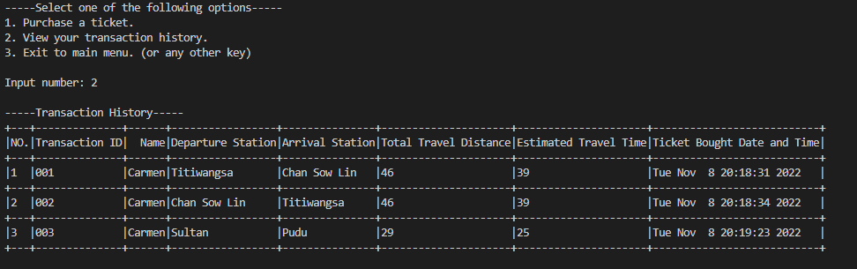

Figure 45 View transaction history

This is the transaction history for customers where they can view all their transaction details and ticket details in table form.

### Login customer 2

Figure 46 Login customer 2

This an additional user that is in the list of customer accounts.

### Station selection safety feature

Figure 47 Station selection safety feature

This is the station selection safety feature to make sure that the user does not set the same station for the current and destination station.

### Station time safety feature

Figure 48 Station time safety feature

This is the time safety feature where it will make sure the user uses the correct time format.

### Admin login page

Figure 49 Admin login page

This is the login page for the admin page.

### Admin home page

Figure 50 Admin home page

This is the home page for the admin. It will display customer transactions, id sorted, name sorted, edit/add stations, and edit and delete transaction.

### Admin view all customer transaction history

Figure 51 Admin view all customer transaction history

This page displays all the transactions of every customer. It includes the id, name, departure station, arrival station, total travel distance, estimated arrival time, and ticket bought date and time.

### Admin view all customer transaction (ID sorted)

Figure 52 Admin view all customer transaction (ID sorted)

This page shows all the transactions sorted by the customer id.

### Admin view all customer transaction (name sorted)

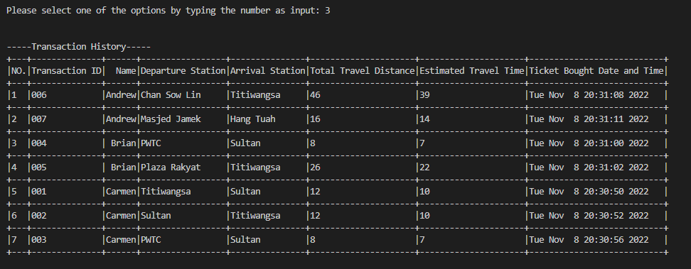

Figure 53 Admin view all customer transaction (name sorted)

This page shows all the transactions sorted by the customer name.

### Admin edit/add station page

Figure 54 Admin edit/add station page

This page allows the admin to edit the station either by the layout of the stations or the details of the stations. It also allows the admin to add a new station to the station list.

### Admin edit a whole station

Figure 55 Admin edit a whole station

For edit a whole station, it will require the admin to select a station id to edit.

When editing station details it will require the admin to enter it in the correct format which is station id, name, travel time, distance, and fee.

### Admin edit specific information

Figure 56 Admin edit specific information

Similar to the edit while station, it allows admin to edit but can select specifically which detail to edit. The admin will have to choose which detail to edit from id, name, time, distance, and fee.

It will require the admin to replace the station name in this case. Once done, it will be shown in the station list where station 4 changes to mars.

### Add station

Figure 57 Add station

In this function it will ask to push or append the new station. New stations can be placed behind or in front of the list.

### Edit station input check

Figure 58 Edit station input check

This checks if the format is correct. If not, it will return to the admin main menu

### Push new station

Figure 59 Push new station

This is the push function where it will require the admin to fill in the details one at a time. Once done, it will confirm with the admin before adding the station.

New station will be added with an id of 0 and is named damansara when using the push function to add in front of the list.

### Append new station

Figure 60 Append new station

Similar to the push function except for adding a new station at the end of the list.

# 4. Conclusion, future works, and reflection

This is the system that we have created as a team which will be presented to FIRST IT Ltd. This system allows the passenger to purchase tickets and make the necessary changes for their ticket and the admin is allowed to make changes to details of the customer ticket and the details of the train stations. With this we hope that we can make a more advanced system that has many more enhance features that could improve the overall quality of the system. Although this was out first major assignment to make this system, we managed to learn simple data structure and implementing linked list into our system that could help us with our projects in the future.

# 5. Appendix: Workload Matrix Table with signature

|  |  |  |  |
| --- | --- | --- | --- |
| Name | TP Number | Workload | Signature |
| Ng Hann Pinn | TP058002 | 25% |  |
| Wang Ju Lian | TP053175 | 25% |  |
| Nicklaus San Yew Joe | TP058303 | 25% |  |
| Lee Hong Yu | TP063138 | 25% |  |